http://www.ici.org/research/stats/mmf/mm_11_05_09

Money Market Mutual Fund Assets
November 5, 2009
Washington, DC, November 5, 2009 - Total money market mutual fund assets decreased by $31.26 billion to $3.339 trillion for the week ended Wednesday, November 4, the Investment Company Institute reported today. Taxable government funds decreased by $17.22 billion, taxable non-government funds decreased by $14.82 billion, and tax-exempt funds increased by $780 million.

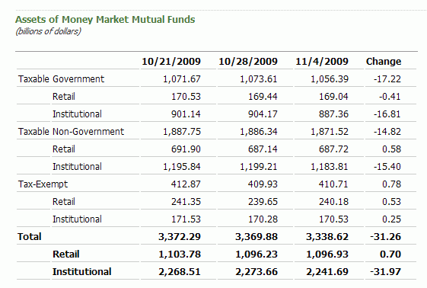

Retail: Assets of retail money market funds increased by $703 million to $1.097 trillion. Taxable government money market fund assets in the retail category decreased by $410 million to $169.04 billion, taxable non-government money market fund assets increased by $580 million to $687.72 billion, and tax-exempt fund assets increased by $530 million to $240.18 billion.
Institutional: Assets of institutional money market funds decreased by $31.97 billion to $2.242 trillion. Among institutional funds, taxable government money market fund assets decreased by $16.81 billion to $887.36 billion, taxable non-government money market fund assets decreased by $15.40 billion to $1.184 trillion, and tax-exempt fund assets increased by $250 million to $170.53 billion.

http://www.ici.org/research/stats/mmf/mm_11_12_09

Money Market Mutual Fund Assets
November 12, 2009
Washington, DC, November 12, 2009 - Total money market mutual fund assets decreased by $3.68 billion to $3.335 trillion for the week ended Wednesday, November 11, the Investment Company Institute reported today. Taxable government funds decreased by $4.68 billion, taxable non-government funds increased by $4.52 billion, and tax-exempt funds decreased by $3.51 billion.

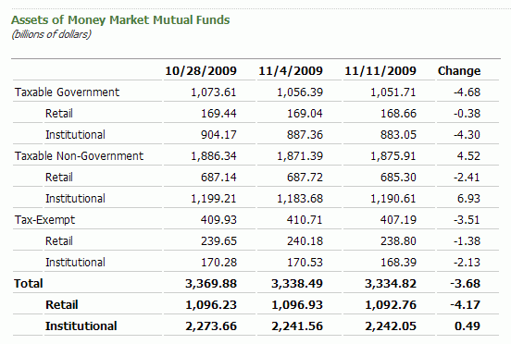

Retail: Assets of retail money market funds decreased by $4.17 billion to $1.093 trillion. Taxable government money market fund assets in the retail category decreased by $380 million to $168.66 billion, taxable non-government money market fund assets decreased by $2.41 billion to $685.30 billion, and tax-exempt fund assets decreased by $1.38 billion to $238.80 billion.
Institutional: Assets of institutional money market funds increased by $493 million to $2.242 trillion. Among institutional funds, taxable government money market fund assets decreased by $4.30 billion to $883.05 billion, taxable non-government money market fund assets increased by $6.93 billion to $1.191 trillion, and tax-exempt fund assets decreased by $2.13 billion to $168.39 billion.

http://www.ici.org/research/stats/mmf/mm_11_19_09

Money Market Mutual Fund Assets
November 19, 2009
Washington, DC, November 19, 2009 - Total money market mutual fund assets increased by $3.71 billion to $3.339 trillion for the week ended Wednesday, November 18, the Investment Company Institute reported today. Taxable government funds increased by $230 million, taxable non-government funds increased by $3.19 billion, and tax-exempt funds increased by $300 million.

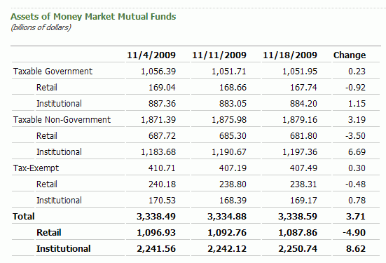

Retail: Assets of retail money market funds decreased by $4.90 billion to $1.088 trillion. Taxable government money market fund assets in the retail category decreased by $920 million to $167.74 billion, taxable non-government money market fund assets decreased by $3.50 billion to $681.80 billion, and tax-exempt fund assets decreased by $480 million to $238.31 billion.
Institutional: Assets of institutional money market funds increased by $8.62 billion to $2.251 trillion. Among institutional funds, taxable government money market fund assets increased by $1.15 billion to $884.20 billion, taxable non-government money market fund assets increased by $6.69 billion to $1.197 trillion, and tax-exempt fund assets increased by $780 million to $169.17 billion.
http://www.ici.org/research/stats/mmf/mm_11_25_09

Money Market Mutual Fund Assets November 25, 2009
Washington, DC, November 25, 2009 - Total money market mutual fund assets decreased by $7.82 billion to $3.330 trillion for the week ended Tuesday, November 24, the Investment Company Institute reported today. Taxable government funds decreased by $3.93 billion, taxable non-government funds decreased by $2.76 billion, and tax-exempt funds decreased by $1.13 billion.
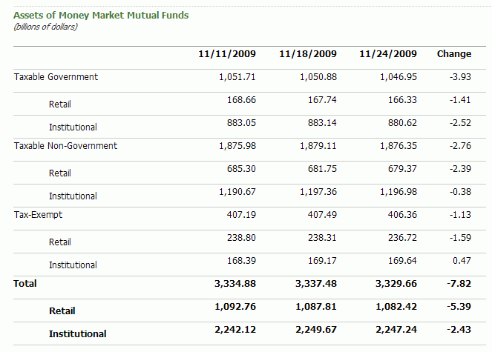
Retail: Assets of retail money market funds decreased by $5.39 billion to $1.082 trillion. Taxable government money market fund assets in the retail category decreased by $1.41 billion to $166.33 billion, taxable non-government money market fund assets decreased by $2.39 billion to $679.37 billion, and tax-exempt fund assets decreased by $1.59 billion to $236.72 billion.
Institutional: Assets of institutional money market funds decreased by $2.43 billion to $2.247 trillion. Among institutional funds, taxable government money market fund assets decreased by $2.52 billion to $880.62 billion, taxable non-government money market fund assets decreased by $380 million to $1.197 trillion, and tax-exempt fund assets increased by $470 million to $169.64 billion.
http://www.ici.org/research/stats/mmf/mm_12_03_09

Money Market Mutual Fund Assets
December 3, 2009
Washington, DC, December 3, 2009 - Total money market mutual fund assets decreased by $8.36 billion to $3.319 trillion for the week ended Wednesday, December 2, the Investment Company Institute reported today. Taxable government funds decreased by $9.35 billion, taxable non-government funds decreased by $950 million, and tax-exempt funds increased by $1.94 billion.
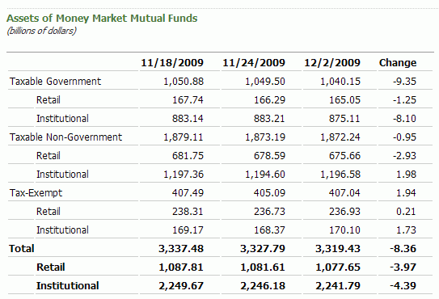

Retail: Assets of retail money market funds decreased by $3.97 billion to $1.078 trillion. Taxable government money market fund assets in the retail category decreased by $1.25 billion to $165.05 billion, taxable non-government money market fund assets decreased by $2.93 billion to $675.66 billion, and tax-exempt fund assets increased by $210 million to $236.93 billion.
Institutional: Assets of institutional money market funds decreased by $4.39 billion to $2.242 trillion. Among institutional funds, taxable government money market fund assets decreased by $8.10 billion to $875.11 billion, taxable non-government money market fund assets increased by $1.98 billion to $1.197 trillion, and tax-exempt fund assets increased by $1.73 billion to $170.10 billion.

http://www.ici.org/research/stats/mmf/mm_12_10_09

Money Market Mutual Fund Assets
December 10, 2009
Washington, DC, December 10, 2009 - Total money market mutual fund assets decreased by $360 million to $3.320 trillion for the week ended Wednesday, December 9, the Investment Company Institute reported today. Taxable government funds decreased by $1.46 billion, taxable non-government funds increased by $3.15 billion, and tax-exempt funds decreased by $2.05 billion.

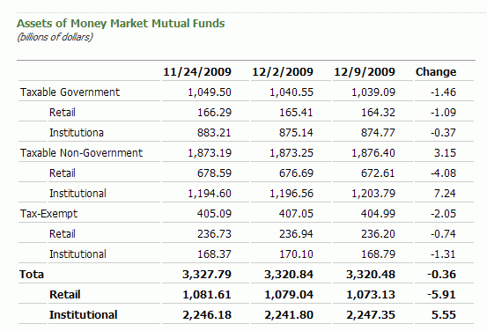

Retail: Assets of retail money market funds decreased by $5.91 billion to $1.073 trillion. Taxable government money market fund assets in the retail category decreased by $1.09 billion to $164.32 billion, taxable non-government money market fund assets decreased by $4.08 billion to $672.61 billion, and tax-exempt fund assets decreased by $740 million to $236.20 billion.

Institutional: Assets of institutional money market funds increased by $5.55 billion to $2.247 trillion. Among institutional funds, taxable government money market fund assets decreased by $370 million to $874.77 billion, taxable non-government money market fund assets increased by $7.24 billion to $1.204 trillion, and tax-exempt fund assets decreased by $1.31 billion to $168.79 billion.

http://www.ici.org/research/stats/mmf/mm_12_17_09

Money Market Mutual Fund Assets
December 17, 2009
Washington, DC, December 17, 2009 - Total money market mutual fund assets decreased by $51.13 billion to $3.269 trillion for the week ended Wednesday, December 16, the Investment Company Institute reported today. Taxable government funds decreased by $17.36 billion, taxable non-government funds decreased by $29.15 billion, and tax-exempt funds decreased by $4.63 billion.

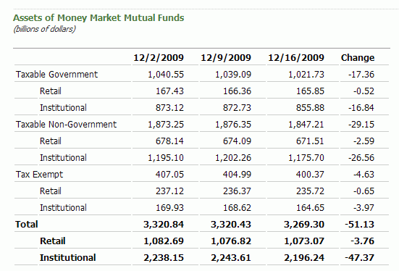

Retail: Assets of retail money market funds decreased by $3.76 billion to $1.073 trillion. Taxable government money market fund assets in the retail category decreased by $520 million to $165.85 billion, taxable non-government money market fund assets decreased by $2.59 billion to $671.51 billion, and tax-exempt fund assets decreased by $650 million to $235.72 billion.
Institutional: Assets of institutional money market funds decreased by $47.37 billion to $2.196 trillion. Among institutional funds, taxable government money market fund assets decreased by $16.84 billion to $855.88 billion, taxable non-government money market fund assets decreased by $26.56 billion to $1.176 trillion, and tax-exempt fund assets decreased by $3.97 billion to $164.65 billion.
http://www.ici.org/research/stats/mmf/mm_12_23_09

Money Market Mutual Fund Assets
December 23, 2009
Washington, DC, December 23, 2009 - Total money market mutual fund assets increased by $2.59 billion to $3.272 trillion for the week ended Tuesday, December 22, the Investment Company Institute reported today. Taxable government funds increased by $7.15 billion, taxable non-government funds decreased by $2.20 billion, and tax-exempt funds decreased by $2.36 billion.
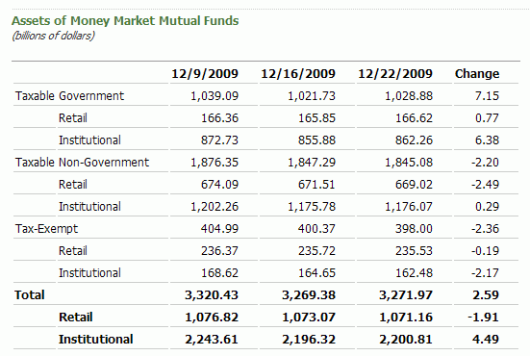

Retail: Assets of retail money market funds decreased by $1.91 billion to $1.071 trillion. Taxable government money market fund assets in the retail category increased by $770 million to $166.62 billion, taxable non-government money market fund assets decreased by $2.49 billion to $669.02 billion, and tax-exempt fund assets decreased by $190 million to $235.53 billion.

Institutional: Assets of institutional money market funds increased by $4.49 billion to $2.201 trillion. Among institutional funds, taxable government money market fund assets increased by $6.38 billion to $862.26 billion, taxable non-government money market fund assets increased by $290 million to $1.176 trillion, and tax-exempt fund assets decreased by $2.17 billion to $162.48 billion.

http://www.ici.org/research/stats/mmf/mm_12_30_09

Money Market Mutual Fund Assets
December 30, 2009
Washington, DC, December 30, 2009 - Total money market mutual fund assets increased by $21.73 billion to $3.294 trillion for the week ended Tuesday, December 29, the Investment Company Institute reported today. Taxable government funds increased by $22.48 billion, taxable non-government funds increased by $580 million, and tax-exempt funds decreased by $1.32 billion.

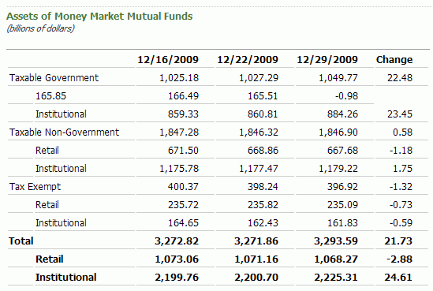

Retail: Assets of retail money market funds decreased by $2.88 billion to $1.068 trillion. Taxable government money market fund assets in the retail category decreased by $980 million to $165.51 billion, taxable non-government money market fund assets decreased by $1.18 billion to $667.68 billion, and tax-exempt fund assets decreased by $730 million to $235.09 billion.

Institutional: Assets of institutional money market funds increased by $24.61 billion to $2.225 trillion. Among institutional funds, taxable government money market fund assets increased by $23.45 billion to $884.26 billion, taxable non-government money market fund assets increased by $1.75 billion to $1.179 trillion, and tax-exempt fund assets decreased by $590 million to $161.83 billion.

http://www.ici.org/research/stats/mmf/mm_01_14_10

Money Market Mutual Fund Assets
January 14, 2010
Washington, DC, January 14, 2010 - Total money market mutual fund assets decreased by $21.67 billion to $3.286 trillion for the week ended Wednesday, January 13, the Investment Company Institute reported today. Taxable government funds decreased by $9.47 billion, taxable non-government funds decreased by $3.14 billion, and tax-exempt funds decreased by $9.06 billion.
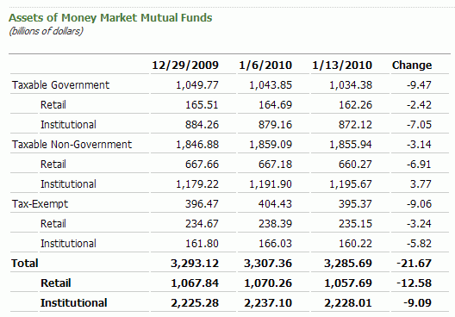
Retail: Assets of retail money market funds decreased by $12.58 billion to $1.058 trillion. Taxable government money market fund assets in the retail category decreased by $2.42 billion to $162.26 billion, taxable non-government money market fund assets decreased by $6.91 billion to $660.27 billion, and tax-exempt fund assets decreased by $3.24 billion to $235.15 billion.

Institutional: Assets of institutional money market funds decreased by $9.09 billion to $2.228 trillion. Among institutional funds, taxable government money market fund assets decreased by $7.05 billion to $872.12 billion, taxable non-government money market fund assets increased by $3.77 billion to $1.196 trillion, and tax-exempt fund assets decreased by $5.82 billion to $160.22 billion.

